X-Line Apollo Single CCT 30W/m 2700K/3000K/4000K/6000K 24V CR80
Features  · 2700/3000/4000/5000/6000K, CRI80  · High power 30W/m, high brightness 6000lm/m  · High efficiency 200lm/W  · 48VDC, high power efficiency  · For office ,industrial, architectural lighting  · Lifespan 40000 hrs,  · 5 years warranty |  |  | 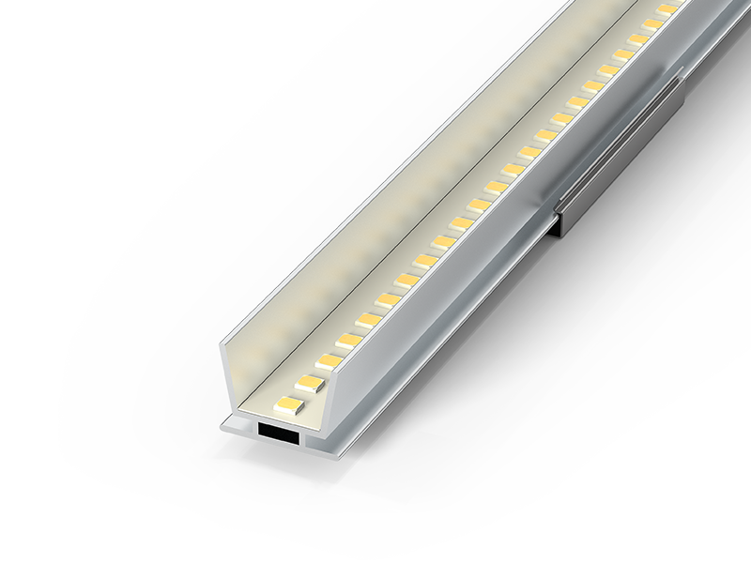
Technical data
Electrical specifications  Working temperature range -20~+60℃ |  |  |  | Storage temperature range -20~+70℃
  Part No.
  Wattage (W/m) | 30
  DC output voltage (V) | 48
  Frequency (Hz) | -
  Dimmable | Yes
  Max. no. of lamps on B16A circuit breaker | -
  Max. no. of lamps on C16A circuit breaker | -
  Photometric specifications
  Colour temperature (CCT) | 2700K  3000K  4000K  6000K
  Luminous efficiency (lm/W ) | 100(4000K)
  Standard deviation of colour | 3 SDCM
  UGR | -
  Mechanical specifications
  Housing material | FPC+Aluminum profile
  Optical cover/ lens material | -
  Width/ diameter (mm) | 18.3
  Cut length (mm)
  Lifespan
  Number of switching cycles | 100,000
  L80/B10 service life at 25°C | 25,000 hrs
  Warranty period | 5 Years
  Application parameters
  EAN | -
  AC input voltage (V) | -
  Power factor | -
  Total harmonic distortion (THD) | -
  Flicker-free | -
  Max. no. of lamps on C10A circuit breaker | -
  CRI (Ra) | 80
  Luminous flux (lm/m) | 5600  5800  6000  5800
  Beam angle (°) | 120°
  Housing Colour | White/Black
  Length/ diameter (mm) | 300/600/1000/1200
  Height (mm) | 14
  Product weight
  L70/B50 service life at 25°C | 40,000 hrs
  L90/B10 service life at 25°C | 20,000 hrs
  Location of installation | -
  Protection type | IP20
Additional product specifications
Type of installation | insertion and fixed

Photometric Information
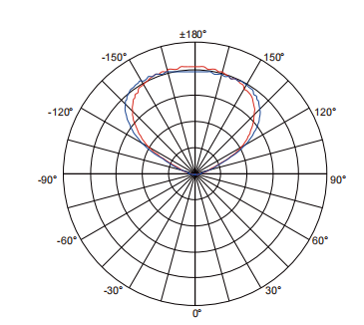
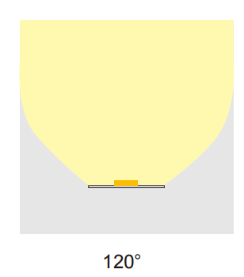

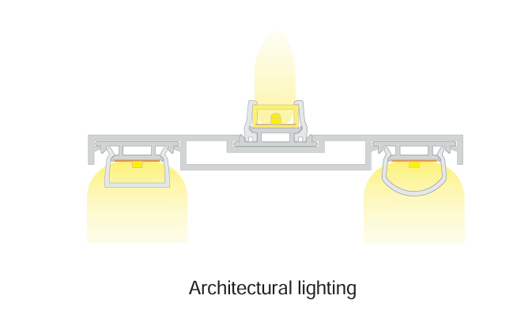
Application
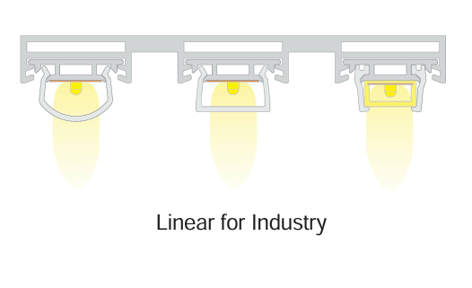
Caution
Power off before replacement
Do not be in violation of any fire regulations when using
Consult qualified electricians for technical support
If the supply cord is damaged, it shall be exclusively replaced by the manufacturer or his service agent or similar qualified person in order to avoid a hazard
Dimensions
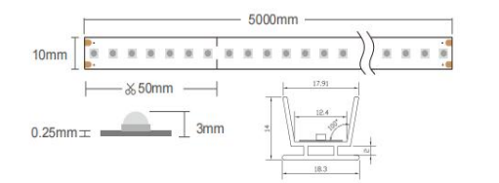
Accessories / Parts (Optional):
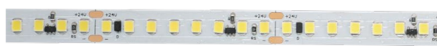
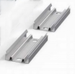
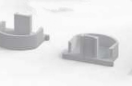

Aluminum slot Clamp Plastic Cover Apollo Flex Strip

